Question Leet code : two sum

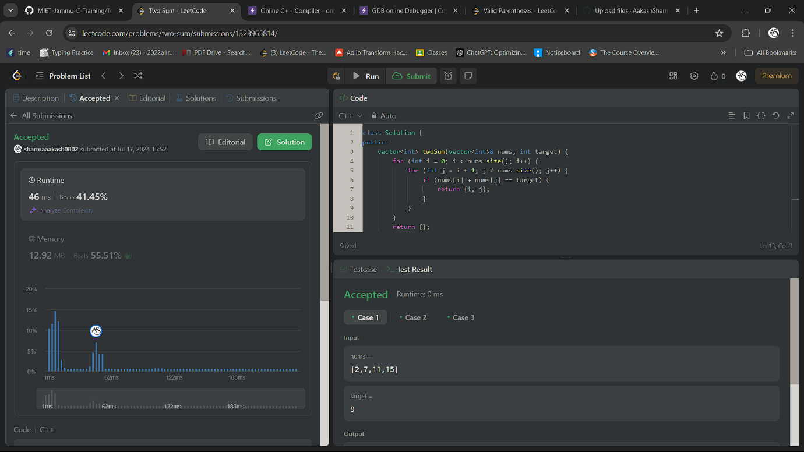

Code:

class Solution {

public:

vector<int> twoSum(vector<int>& nums, int target) {

for (int i = 0; i < nums.size(); i++) {

for (int j = i + 1; j < nums.size(); j++) {

if (nums[i] + nums[j] == target) {

return {i, j};

}

}

}

return {};

}

};

Question 1)Write a program to display the array element.

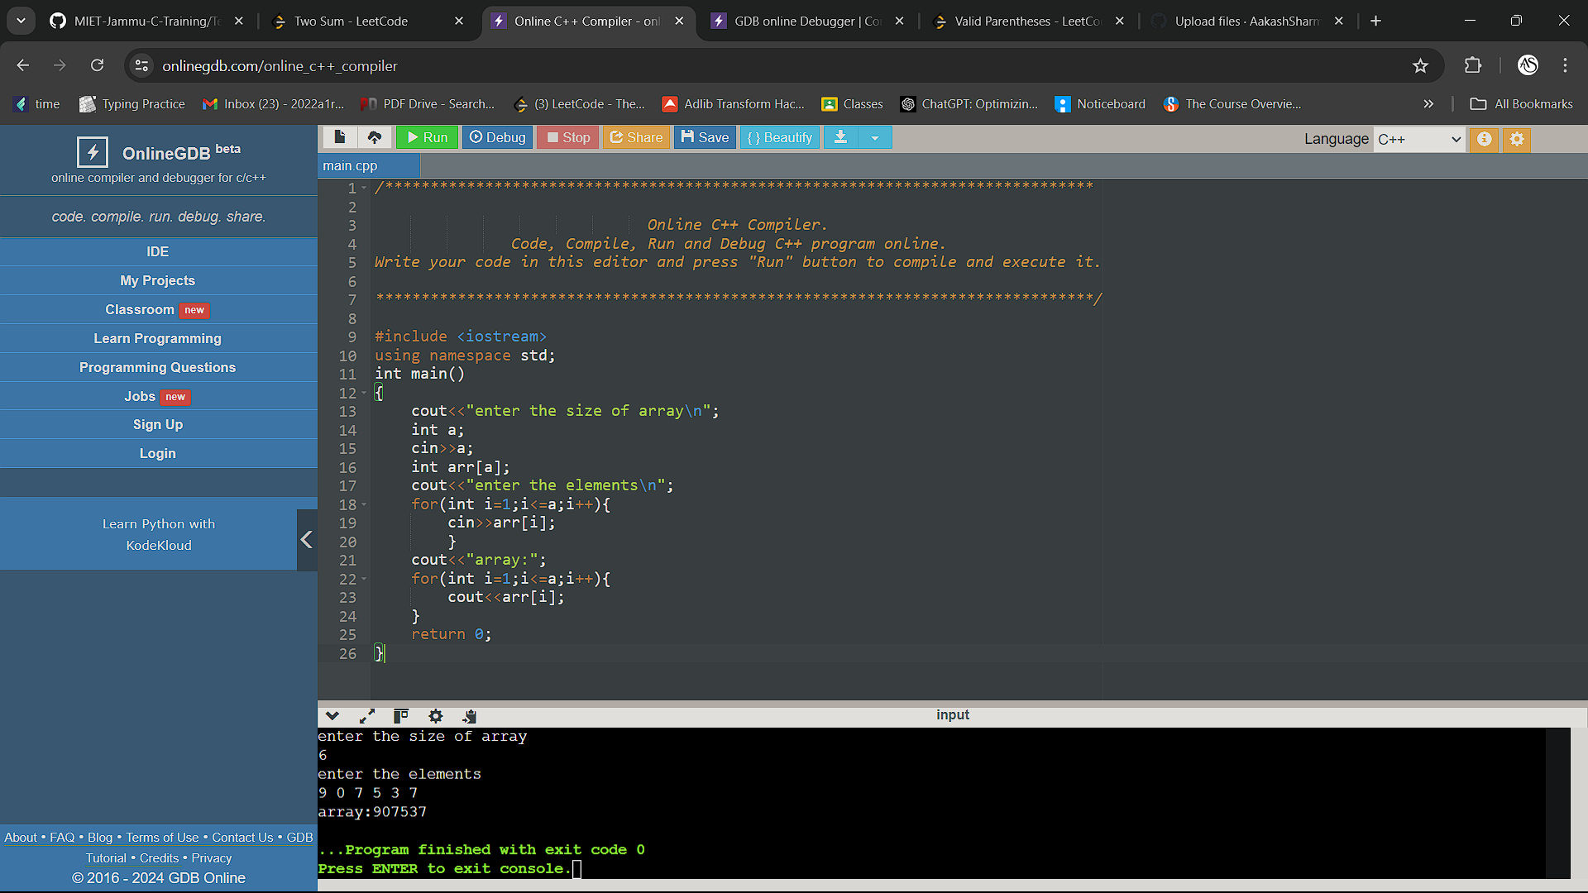

Code

#include <iostream>

using namespace std;

int main()

{

cout<<"enter the size of array\n";

int a;

cin>>a;

int arr[a];

cout<<"enter the elements\n";

for(int i=1;i<=a;i++){

cin>>arr[i];

}

cout<<"array:";

for(int i=1;i<=a;i++){

cout<<arr[i];

}

return 0;

}

Question 2)write a progam to find the max element from the list

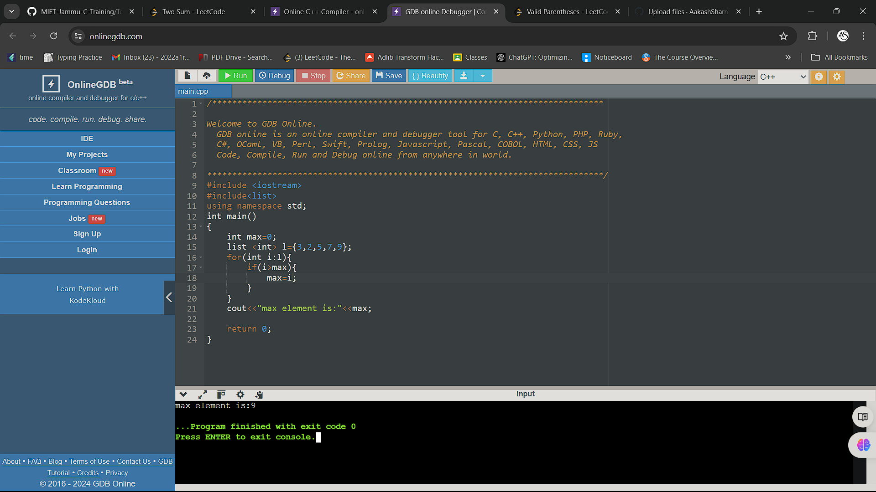

Code:

#include <iostream>

#include<list>

using namespace std;

int main()

{

int max=0;

list <int> l={3,2,5,7,9};

for(int i:l){

if(i>max){

max=i;

}

}

cout<<"max element is:"<<max;

return 0;

}